WELLNESS &  PREVENTION  SERVICES |  |  |  |  |  | FEBRURARY NEWSLETTER
 |  |  |  |  |  | SPRING 2019
The shortest (coldest) month of the year!
While February is the shortest month of the year, it’s one of the most bitterly cold here in the High Country. This cold makes the month drag forever! Despite this frigidness, make sure you take the few weekends this month to focus on your social wellness. Catch up with friends you might not have seen yet this year, and hang out with those who make you happiest.

Eating Disorder Awareness Month
This month is Eating Disorder Awareness Month. Eating disorders typically begin between 18 and 21 years of age, according to the National Eating Disorders Association (NEDA). The association estimates that between 10 and 20% of women and 4 to 10% of men in college suffer from an eating disorder, and rates are on the rise. Disordered eating needs to be addressed by a registered dietitian. In our office, we have Janna Lyons MA, RD. She provides one on one nutrition counseling and education to students for a variety of concerns, including disordered eating, eating healthy on a budget, food intolerances or allergies, weight loss, diabetes, and more. Any student, undergraduate or graduate, can schedule an appointment with Janna by calling the office or scheduling in person at the WPS Office.
 |  |  |  |  | 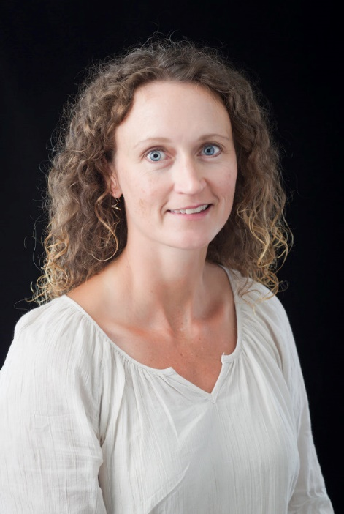
Fast  Fact |  | One of the eight dimensions of Wellness is Spiritual Wellness! The National Wellness Institute says spiritual wellness follows the following tenets:  1) It is better to ponder the meaning of life for ourselves and to be tolerant of the beliefs of others than to close our minds and become intolerant; 2) It is better to live each day in a way that is consistent with our values and beliefs than to do otherwise and feel untrue to ourselves.

GAMMA  GAMMA is a Peer Educator group composed of Greek students from Appalachian’s Fraternity and Sorority organizations. The purpose of GAMMA is to provide targeted health information programming to increase health knowledge and promote healthy decision making. These students are in the process of developing ‘Greek Guides’; they will be educating students on mental health, interpersonal relationships, and substance use as they relate to fraternity and sorority life and engagement. GAMMA aims to decrease stigma related to students who partake in Fraternity and Sorority life, and elevate the experiences of those students. Go GAMMA! |  |  |  | Peer Educator Updates  Our Wellness Educators for Change, Advocacy, and student Needs will be tabling in Plemmons Student Union and Leon Levine Health Sciences building this semester! Be on the lookout for WE CAN members to learn more about the organization, the upcoming Project Condom (More on that next month!), and April’s Sex Positive week!  If you’d like to learn more about WE CAN, the presentations they give, or how to schedule a presentation for your class/club/organization, check them out on AppSync by searching ‘Wellness Educators for Change, Advocacy, and student Needs”! |  |  |  | Student Highlight  Lexi Gross is our Post Master Trainee in Mental and Social Well-being. She provides substance abuse and general mental health counseling to students. She does outreach with the Multicultural Student Development centers as well as other with other student groups regarding substance use, harm reduction, stress management, and healthy relationships. Lexi also works with the Collegiate Recovery Community, facilitating meetings and events throughout the semester for students looking to enjoy their college experience while supporting their recovery. Lexi graduated from Appalachian State's Clinical Mental Health Counseling Program during which she completed her internship at Wellness and Prevention Services!
February Events
- Check back next month!
 | Website: |  |  |  | Contact: |  |  |  | Email:
 | wellness.appstate.edu |  |  |  | 828.262.3148 |  |  |  | prevention@appstate.edu
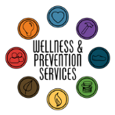
What’s happening
in Wellness?

